Welcome to Saksoft



Table of Contents
1 Saksoft Overview 2.1.2
2 Let’s get IT Started 2.1.3
2.1 If you need help with the IT systems 2.1.3
3 Important Portals you would be using 2.1.4
3.1 HR Management System : Empxtrack 3.1.4
3.1.1 What will I see in this portal ? 3.1.4
3.1.2 Why should I login? 3.1.4
3.1.3 How do I login? 3.1.4
3.2 My Compensation My way : Allsec 3.2.4
3.2.1 What will I see in this portal ? 3.2.4
3.2.2 Why should I login? 3.2.4
3.2.3 How do I login? 3.2.4
3.3 Your Knowledge Portal : SAKVAULT 3.3.5
3.3.1 What will I see in this portal ? 3.3.5
3.3.2 Why should I login? 3.3.5
3.3.3 How do I login? 3.3.5
Tips : 3.3.5
3.4 HR Policies 3.4.5
4 Salary Credit and Insurance Policy 3.4.6
4.1 Bank Account 4.1.6
4.1.1 Scenario 1 4.1.6
4.1.2 Scenario 2 4.1.6
4.2 Insurance 4.2.6
5 Key Contacts 4.2.7

Saksoft Overview

Saksoft Limited is a leading player in providing digital transformation solutions to help businesses stay relevant in a highly connected, rapidly evolving world. Saksoft is a niche technology specialist that provides a comprehensive suite of business transformation, information management, application development and testing services. In short, Saksoft helps their clients level the playing field by helping them transform their business spaces.

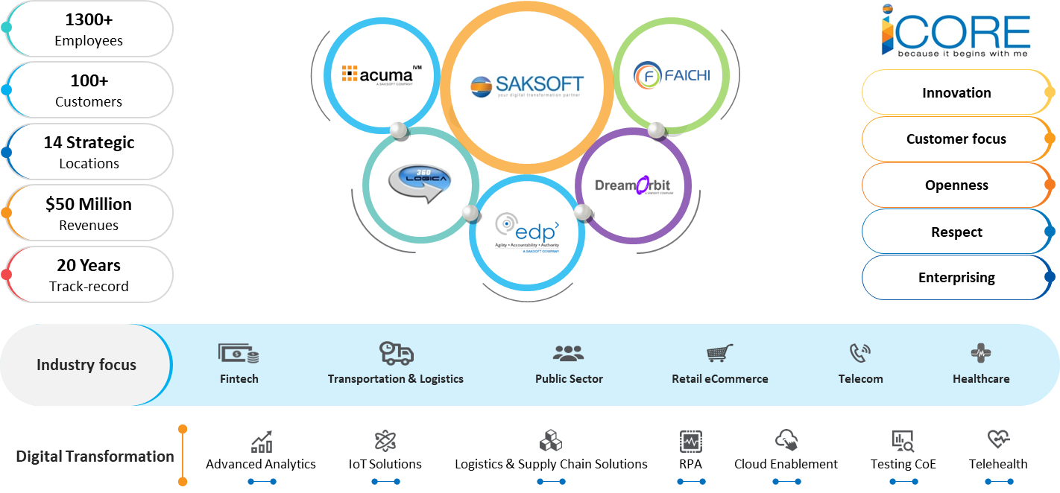

Let’s get IT Started

- At your first log in, you will be prompted to change your password. The minimum password length is 8 characters.
- All applications use the network User ID and Password. Email, Network, VSS and TFS are integrated.
- In case, you are provided with a computer by the company, your machine will be configured to your Department’s prerequisite software. If you need additional support, please approach your Manager for approval
- Please ensure confidentiality and integrity of your system infrastructure and do not share your password or username with anyone else. It should be shared only at the request of the Network administrator and with the approval of your manager

If you need help with the IT systems

- You can visit http://techsupport.saksoft.co.in and raise a ticket
- You can email us at sysadmin_ndc@saksoft.co.in
- You may also reach us at the following contact numbers:
Kishor Dhumal- 8956022572

Important Portals you would be using

HR Management System : Saktrack

What will I see in this portal ?
- Employee help desk, Leave application module, Travel Module, Holiday List etc
- Your personal data profile
- Employee Handbook,

Why should I login?
- Timesheet: You need to punch in the daily attendance in the timesheet module in Empxtrack. The timesheet needs to be submitted weekly latest by Sunday, post which it will be blocked to edit.
- Leave and Travel Applications
- Update your skills periodically
- Employee Handbook – Details of all the various HR policies and procedures

How do I login?
- URL : https://saktrack.saksoft.com/login

My Compensation My way : Allsec

What will I see in this portal ?
- Your Payslips, Investment declaration ,Tax submission forms,Tax calculations
- Choose your preferred compensation structure

Why should I login?
- Update your preferred Compensation Structure,Update your investment declaration ,Submit your tax proof

How do I login?
- URL : https://www.allsechro.com/memberlogin/SmartLogic/web_Signon.aspx
- Your login credential will be shared through email after the 1st Salary pay-out.

Your Knowledge Portal : SAKVAULT

What will I see in this portal ?
- Success Stories – Details about some of our largest clients
- Presentations, Induction Videos, Employee testimonials,
- Innovations & Initiatives happening within the SAKSOFT,
- New Customer Wins,
- Did you know facts about the group

Why should I login?
- Get to know your company better,
- Understand the various success stories and innovations happening within the group
- Access various collaterals that you might need
- Access the training calendar and register yourself for the program you are interested in

How do I login?
- URL : http://sakvault.saksoft.com
- Use your official ID to login and set your own password

Tips :
- Book Mark these URL’s
- Save the credentials in a notepad for easy access
- Do not share the credentials with any one

HR Policies

All HR Policies are detailed in the Employee Handbook. Please logon to Empxtrack and choose the relevant employee handbook pertaining to your geography, from the useful links section.

Salary Credit and Insurance Policy

Bank Account

Scenario 1
- HR: Your salary will be credited to a HDFC bank account number. If you have one, please share the Bank Account Number and IFSC Code.
You : I already have an account with HDFC Bank. So can you credit salary to this account?
- HR : Yes, provided it is a Salary Account. Please check with your bank and confirm if the account is a salary account.
You: No it is not a Salary Account? Can you help convert my savings account to salary account?
- HR: Yes, we will initiate the process with your Bank

Scenario 2
- HR: Your salary will be credited to a HDFC bank account number. If you have one, please share the Bank Account Number and IFSC Code.
You : No I don’t have a HDFC Bank Account
- HR: We will provide you an authorization letter which you would need to submit the bank to open a new HDFC Bank Account
You: Are there any other document that I need to open a bank account
- HR: You need to have a local address proof, photo id proof and 1 passport size picture and visit the nearest HDFC branch for the same.

Insurance
- You : Does Saksoft provide a medical insurance cover
- HR: Yes . Medical Insurance cover for all permanent employees, their Spouse and two Children
  - Insurer- Oriental Insurance Co Ltd
  - Service Provider/TPA- Family Health Plan Ltd
  - Family Floater Sum inured of 1 Lac
  - Day one coverage for employees
  - Coverage ceases on resignation/termination/retirment

Key Contacts

Jennifer D, Executive HR, 8220101749

Vikas Sharma, Sr. HR Manager, 9422057593

Juhi Gupte, Assistant Manager – Recruitment, 8956022573

Kanchan Kundnani, Executive HR – Recruitment - 8956022574

